1.   
/Users/Rasa/Desktop/Screen Shot 2017-05-25 at 7.26.10 AM.png

1. Screen%20Shot%202017-05-25%20at%207.27.41%20AM.png
2. Screen%20Shot%202017-05-25%20at%207.27.36%20AM.png
3. Screen%20Shot%202017-05-25%20at%207.27.22%20AM.png
4. Screen%20Shot%202017-05-25%20at%207.27.32%20AM.png

How did you get your answer? _____________________________________________________  
  
______________________________________________________________________________

2.

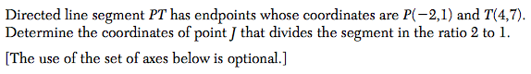

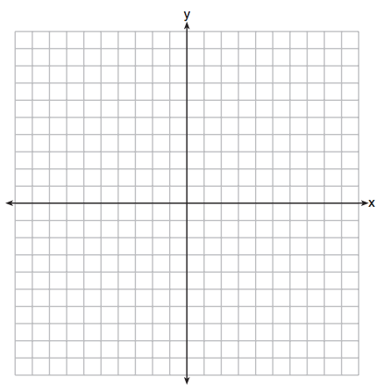

3. *Solve for all angles in the diagram to receive credit.*  
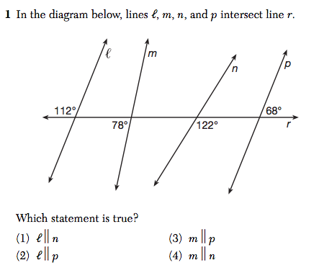

4. *Solve for all angles in the diagram to receive credit.*  
